**Міністерство освіти і науки України**

**Національний технічний університет України**

**«Київський політехнічний інститут імені Ігоря Сікорського»**

**Факультет інформатики та обчислювальної техніки**

**Кафедра обчислювальної техніки**

**Лабораторна робота №5**

з дисципліни

«Об’єктно орієнтоване програмування»

на тему

“Розробка багатовіконного інтерфейсу

користувача для графічного редактора об’єктів”

Виконав: Перевірив:

Студент групи ІМ-22 Порєв В.М.

Кушнір Микола Миколайович

номер у списку групи: 13

Київ 2023

**Мета**

Отримати вміння та навички програмувати багатовіконний інтерфейс програми на С++ в об’єктно-орієнтованому стилі.

**Завдання**

**1.** Створити у середовищі MS Visual Studio C++ проект Desktop

Application з ім’ям **Lab5**.

**2.** Написати вихідний текст програми згідно варіанту завдання.

**3.** Скомпілювати вихідний текст і отримати виконуваний файл програми.

**4.** Перевірити роботу програми. Налагодити програму.

**5.** Проаналізувати та прокоментувати результати та вихідний текст програми.

**6.** Оформити звіт.

**Умови завдання за варіантом (Ж = 13):**

* Глобальний статичний об’єкт класу ***MyEditor*** у вигляді **Singleton Меєрса** *(13 % 2 ≠ 0)*

**Вихідні тексти файлів програми**

**Lab5.kt**

package com.oop.lab5  
  
import android.os.Bundle  
import androidx.appcompat.app.AppCompatActivity

import com.oop.lab5.my_editor.MyEditor  
import com.oop.lab5.my_table.MyTable  
import com.oop.lab5.file_manager.FileManager  
import com.oop.lab5.main_toolbar.MainToolbar  
import com.oop.lab5.objects_toolbar.ObjectsToolbar  
import com.oop.lab5.paint_view.PaintView  
import com.oop.lab5.shape.Shape

class Lab5 : AppCompatActivity() {  
 private lateinit var editor: MyEditor  
 private lateinit var table: MyTable  
 private lateinit var fileManager: FileManager  
 private lateinit var mainToolbar: MainToolbar  
 private lateinit var objectsToolbar: ObjectsToolbar

override fun onCreate(savedInstanceState: Bundle?) {  
 super.onCreate(savedInstanceState)  
 setContentView(R.layout.*main_activity*)

*// Стартові налаштування MyTable* table = MyTable()  
 table.setOnHideTableListener **{** hideTable() **}** table.setOnSelectRowListener **{** rowIndex **->** editor.selectShape(rowIndex) **}** table.setOnCancelRowsListener **{** rowsIndices **->** editor.cancelShapes(rowsIndices) **}** table.setOnDeleteRowsListener **{** rowsIndices **->** editor.deleteShapes(rowsIndices) **}** *supportFragmentManager* .beginTransaction()  
 .add(R.id.*table_container*, table)  
 .hide(table)  
 .commit()

*// Стартові налаштування MyEditor* editor = MyEditor.getInstance()  
 editor.onCreate(this)  
 val paintView = findViewById<PaintView>(R.id.*paint_view*)  
 paintView.handler = editor  
 editor.paintUtils = paintView  
 editor.setOnNewShapeListener **{** shape **->** table.addRow(editor.serializeShape(shape))  
 **}** editor.setOnUndoListener **{** table.onUndo() **}** editor.setOnClearAllListener **{** table.onClearAll() **}**

*// Стартові налаштування MainToolbar* mainToolbar = findViewById(R.id.*main_toolbar*)  
 mainToolbar.onCreate(editor)  
 mainToolbar.setFileListeners(  
 **{** fileManager.files(*supportFragmentManager*) **}**,  
 **{** fileManager.save() **}**,  
 **{** fileManager.saveAs(*supportFragmentManager*) **}** )  
 mainToolbar.setTableListener **{** if (!table.isDisplayed) showTable()  
 else hideTable()  
 **}** mainToolbar.setObjListeners(::selectObj, ::cancelObj)

*// Стартові налаштування ObjectsToolbar* objectsToolbar = findViewById(R.id.*objects_toolbar*)  
 objectsToolbar.onCreate(editor)  
 objectsToolbar.setObjListeners(::selectObj, ::cancelObj)

*// Стартові налаштування FileManager* fileManager = FileManager(this)  
 fileManager.onCreate **{** fileName **->** mainToolbar.setFileName(fileName)  
 **}** fileManager.setOnFileListeners(  
 **{** newFileName **->** mainToolbar.setFileName(newFileName)  
 editor.serializeDrawing()  
 **}**,  
 **{** fileName, serializedDrawing **->** mainToolbar.setFileName(fileName)  
 editor.deserializeDrawing(serializedDrawing)  
 **}**,  
 **{** editor.serializeDrawing() **}**,  
 **{** _, newFileName **->** if (newFileName != null) {  
 mainToolbar.setFileName(newFileName)  
 if (!editor.isDrawingEmpty()) editor.clearAll()  
 }  
 **}** )  
 }

override fun onDestroy() {  
 super.onDestroy()  
 if (table.isDisplayed) hideTable()  
 }

private fun showTable() {  
 table.isDisplayed = true  
 *supportFragmentManager* .beginTransaction()  
 .show(table)  
 .commit()  
 mainToolbar.onShowTable()  
 }

private fun hideTable() {  
 table.isDisplayed = false  
 *supportFragmentManager* .beginTransaction()  
 .hide(table)  
 .commit()  
 mainToolbar.onHideTable()  
 }

private fun selectObj(shape: Shape) {  
 mainToolbar.onSelectObj(shape)  
 objectsToolbar.onObjSelect(shape)  
 editor.start(shape)  
 }

private fun cancelObj() {  
 mainToolbar.onCancelObj()  
 objectsToolbar.onObjCancel()  
 editor.close()  
 }  
}

**PaintUtils.kt**

package com.oop.lab5.paint_view  
  
import android.graphics.Canvas

interface PaintUtils {  
 val drawnShapesCanvas: Canvas  
 val rubberTraceCanvas: Canvas

fun repaint()  
 fun clearCanvas(canvas: Canvas)  
}

**PaintView.kt**

package com.oop.lab5.paint_view  
  
import android.content.Context  
import android.graphics.Bitmap  
import android.graphics.Canvas  
import android.graphics.Color  
import android.graphics.PorterDuff  
import android.util.AttributeSet  
import android.view.MotionEvent  
import android.view.View

import com.oop.lab5.my_editor.PaintMessagesHandler

class PaintView(context: Context, attrs: AttributeSet?):  
 View(context, attrs),  
 PaintUtils {  
 lateinit var handler: PaintMessagesHandler

override lateinit var drawnShapesCanvas: Canvas  
 override lateinit var rubberTraceCanvas: Canvas

private lateinit var drawnShapesBitmap: Bitmap  
 private lateinit var rubberTraceBitmap: Bitmap

override fun onSizeChanged(w: Int, h: Int, oldw: Int, oldh: Int) {  
 super.onSizeChanged(w, h, oldw, oldh)  
 drawnShapesBitmap = Bitmap.createBitmap(w, h, Bitmap.Config.*ARGB_8888*)  
 drawnShapesCanvas = Canvas(drawnShapesBitmap)  
 rubberTraceBitmap = Bitmap.createBitmap(w, h, Bitmap.Config.*ARGB_8888*)  
 rubberTraceCanvas = Canvas(rubberTraceBitmap)  
 }

override fun onDraw(canvas: Canvas) {  
 super.onDraw(canvas)  
 if (!handler.isRubberTraceModeOn) {  
 handler.onPaint()  
 canvas.drawBitmap(drawnShapesBitmap, 0F, 0F, null)  
 } else {  
 canvas.drawBitmap(drawnShapesBitmap, 0F, 0F, null)  
 canvas.drawBitmap(rubberTraceBitmap, 0F, 0F, null)  
 }  
 }

override fun onTouchEvent(event: MotionEvent): Boolean {  
 super.onTouchEvent(event)  
 val x = event.*x* val y = event.*y* when (event.*action*) {  
 MotionEvent.*ACTION_DOWN* -> handler.onFingerTouch(x, y)  
 MotionEvent.*ACTION_MOVE* -> handler.onFingerMove(x, y)  
 MotionEvent.*ACTION_UP* -> handler.onFingerRelease()  
 }  
 return true  
 }

override fun repaint() {  
 invalidate()  
 }

override fun clearCanvas(canvas: Canvas) {  
 canvas.drawColor(Color.*TRANSPARENT*, PorterDuff.Mode.*MULTIPLY*)  
 }  
}

**PaintMessagesHandler.kt**

package com.oop.lab5.shape_editor

interface PaintMessagesHandler {  
 var isRubberTraceModeOn: Boolean

fun onFingerTouch(x: Float, y: Float)  
 fun onFingerMove(x: Float, y:Float)  
 fun onFingerRelease()  
 fun onPaint()  
}

**MyEditor.kt**

package com.oop.lab5.my_editor  
  
import android.content.Context  
import java.lang.StringBuilder

import com.oop.lab5.paint_view.PaintUtils  
import com.oop.lab5.shape.Shape  
import com.oop.lab5.shape.PointShape  
import com.oop.lab5.shape.LineShape  
import com.oop.lab5.shape.RectShape  
import com.oop.lab5.shape.EllipseShape  
import com.oop.lab5.shape.SegmentShape  
import com.oop.lab5.shape.CuboidShape  
import com.oop.lab5.tooltip.Tooltip

class MyEditor private constructor(): PaintMessagesHandler {  
 companion object {  
 @Volatile  
 private lateinit var instance: MyEditor

fun getInstance(): MyEditor {  
 *synchronized*(this) **{** if (!::instance.*isInitialized*) instance = MyEditor()  
 return instance  
 **}** }  
 }

lateinit var paintUtils: PaintUtils  
 override var isRubberTraceModeOn = false

lateinit var shapes: Array<Shape>  
 var currentShape: Shape? = null  
 private set  
 private val drawnShapes = *mutableListOf*<Shape>()  
 private val selectedShapesIndices = *mutableListOf*<Int>()

private var onNewShapeListener: ((Shape) -> Unit)? = null

private lateinit var onUndoListener: () -> Unit  
 private lateinit var onClearAllListener: () -> Unit

private lateinit var emptyDrawingTooltip: Tooltip

fun onCreate(context: Context) {  
 shapes = *arrayOf*(  
 PointShape(context),  
 LineShape(context),  
 RectShape(context),  
 EllipseShape(context),  
 SegmentShape(context),  
 CuboidShape(context),  
 )  
 emptyDrawingTooltip = Tooltip(context)  
 }

fun start(shape: Shape) {  
 currentShape = shape  
 }

fun close() {  
 currentShape = null  
 }

override fun onFingerTouch(x: Float, y: Float) {  
 currentShape?.*apply* **{** setStart(x, y)  
 setEnd(x, y)  
 **}** }

override fun onFingerMove(x: Float, y: Float) {  
 currentShape?.*let* **{** isRubberTraceModeOn = true  
 paintUtils.clearCanvas(paintUtils.rubberTraceCanvas)  
 **it**.setEnd(x, y)  
 **it**.showRubberTrace(paintUtils.rubberTraceCanvas)  
 paintUtils.repaint()  
 **}** }

override fun onFingerRelease() {  
 currentShape = currentShape?.*let* **{** isRubberTraceModeOn = false  
 if (**it**.isValid()) addShape(**it**)  
 paintUtils.repaint()  
 **it**.getInstance()  
 **}** }

override fun onPaint() {  
 paintUtils.clearCanvas(paintUtils.rubberTraceCanvas)  
 paintUtils.clearCanvas(paintUtils.drawnShapesCanvas)  
 drawnShapes.*forEach* **{** if (selectedShapesIndices.contains(drawnShapes.indexOf(**it**))) {  
 **it**.showSelected(paintUtils.drawnShapesCanvas)  
 } else {  
 **it**.showDefault(paintUtils.drawnShapesCanvas)  
 }  
 **}** }

fun serializeShape(shape: Shape): String {  
 val str = StringBuilder()  
 val coords = shape.getCoords()  
 val fields = *arrayOf*(  
 shape.name,  
 coords.left.toInt(),  
 coords.top.toInt(),  
 coords.right.toInt(),  
 coords.bottom.toInt()  
 )  
 (0..<(fields.size - 1)).*forEach* **{** str.append("${fields[**it**]}\t")  
 **}** str.append("${fields.*last*()}")  
 return str.toString()  
 }

fun deserializeShape(serializedShape: String): Shape {  
 val data = serializedShape.*split*("\t")  
 val fields = object {  
 val name = data[0]  
 val startX = data[1].*toFloat*()  
 val startY = data[2].*toFloat*()  
 val endX = data[3].*toFloat*()  
 val endY = data[4].*toFloat*()  
 }  
 val shape = shapes.*find* **{** fields.name == **it**.name **}**!!.getInstance()  
 shape.setStart(fields.startX, fields.startY)  
 shape.setEnd(fields.endX, fields.endY)  
 return shape  
 }

fun serializeDrawing(): String {  
 val str = StringBuilder()  
 drawnShapes.*forEach* **{** str.append("${serializeShape(**it**)}\n")  
 **}** return str.toString()  
 }

fun deserializeDrawing(serializedDrawing: String) {  
 if (!isDrawingEmpty()) clearAll()  
 val serializedShapes = serializedDrawing.*dropLast*(1).*split*("\n")  
 serializedShapes.*forEach* **{** addShape(deserializeShape(**it**))  
 **}** paintUtils.repaint()  
 }

fun addShape(shape: Shape) {  
 drawnShapes.add(shape)  
 onNewShapeListener?.invoke(shape)  
 }

fun selectShape(index: Int) {  
 selectedShapesIndices.add(index)  
 paintUtils.repaint()  
 }

fun cancelShapes(indices: List<Int>) {  
 for (index in indices) {  
 selectedShapesIndices.remove(index)  
 }  
 paintUtils.repaint()  
 }

fun deleteShapes(indices: List<Int>) {  
 if (!isDrawingEmpty()) {  
 for (index in indices.*sorted*().*sortedDescending*()) {  
 selectedShapesIndices.remove(index)  
 drawnShapes.removeAt(index)  
 }  
 paintUtils.repaint()  
 } else {  
 emptyDrawingTooltip.create("Полотно уже порожнє").display()  
 }  
 }

fun isDrawingEmpty(): Boolean {  
 return drawnShapes.isEmpty()  
 }

fun undo() {  
 deleteShapes(*listOf*(drawnShapes.size - 1))  
 onUndoListener()  
 }

fun clearAll() {  
 deleteShapes((0..<drawnShapes.size).*toList*())  
 onClearAllListener()  
 }

fun setOnNewShapeListener(listener: ((Shape) -> Unit)?) {  
 onNewShapeListener = listener  
 }

fun setOnUndoListener(listener: () -> Unit) {  
 onUndoListener = listener  
 }

fun setOnClearAllListener(listener: () -> Unit) {  
 onClearAllListener = listener  
 }  
}

**Shape.kt**

package com.oop.lab5.shape  
  
import android.content.Context  
import android.graphics.Canvas

import android.graphics.DashPathEffect  
import android.graphics.Paint

import android.graphics.RectF  
import com.oop.lab5.R

abstract class Shape(private val context: Context) {  
 abstract val name: String  
 val associatedIds = *mutableMapOf*<String, Int>()

protected var startX: Float = 0F  
 protected var startY: Float = 0F  
 protected var endX: Float = 0F  
 protected var endY: Float = 0F

fun setStart(x: Float, y: Float) {  
 startX = x  
 startY = y  
 }

fun setEnd(x: Float, y: Float) {  
 endX = x  
 endY = y  
 }

abstract fun isValid(): Boolean

abstract fun getInstance(): Shape

fun getCoords(): RectF {  
 return RectF(startX, startY, endX, endY)  
}

protected open fun getOutlinePaint(mode: String): Paint {  
 return Paint().*apply* **{** *isAntiAlias* = true  
 *style* = Paint.Style.*STROKE  
 strokeWidth* = 7F  
 val modeActions = *mapOf*(  
 "default" *to* **{** *color* = context.getColor(R.color.*black*)  
 **}**,  
 "selected" *to* **{** *color* = context.getColor(R.color.*selected_outline_color*)  
 **}**,  
 "rubberTrace" *to* **{** *color* = context.getColor(R.color.*dark_blue*)  
 val dashLen = 30F  
 val spaceLen = 15F  
 val dashDensity = *floatArrayOf*(dashLen, spaceLen, dashLen, spaceLen)  
 *pathEffect* = DashPathEffect(dashDensity, 0F)  
 **}**,  
 )  
 modeActions[mode]?.invoke()  
 **}**}

protected open fun getFillingPaint(mode: String): Paint {  
 return Paint().*apply* **{** *isAntiAlias* = true  
 *style* = Paint.Style.*FILL* **}**}  
 abstract fun show(canvas: Canvas, outlinePaint: Paint, fillingPaint: Paint?)

abstract fun showDefault(canvas: Canvas)

abstract fun showSelected(canvas: Canvas)

fun showRubberTrace(canvas: Canvas) {  
 show(canvas, getOutlinePaint("rubberTrace"), null)  
 }  
}

**PointShape.kt**

package com.oop.lab5.shape  
  
import android.content.Context  
import android.graphics.Canvas  
import android.graphics.Paint  
import com.oop.lab5.R

class PointShape(private val context: Context): Shape(context) {  
 override val name = context.getString(R.string.*point*)

override fun isValid(): Boolean {  
 return true  
 }

override fun getInstance(): Shape {  
 return PointShape(context, editor).*also* **{  
 it**.associatedIds.putAll(this.associatedIds)  
 **}** }

override fun getOutlinePaint(): Paint {  
 return super.getOutlinePaint().*apply* **{** *strokeWidth* = 15F  
 **}** }  
 override fun getRubberTracePaint(): Paint {  
 return super.getRubberTracePaint().*apply* **{** *strokeWidth* = 15F  
 **}** }

override fun show(canvas: Canvas, outlinePaint: Paint, fillingPaint: Paint?) {  
 canvas.drawPoint(startX, startY, outlinePaint)  
 }

override fun showDefault(canvas: Canvas) {  
 show(canvas, getOutlinePaint("default"), null)  
 }

override fun showSelected(canvas: Canvas) {  
 show(canvas, getOutlinePaint("selected"), null)  
 }  
}

**LineShape.kt**

package com.oop.lab5.shape  
  
import android.content.Context  
import android.graphics.Canvas  
import android.graphics.Paint  
import com.oop.lab5.R

class LineShape(private val context: Context): Shape(context) {  
 override val name = context.getString(R.string.*line*)

override fun isValid(): Boolean {  
 return (startX != endX || startY != endY)  
 }

override fun getInstance(): Shape {  
 return LineShape(context, editor).*also* **{  
 it**.associatedIds.putAll(this.associatedIds)  
 **}** }

override fun show(canvas: Canvas, outlinePaint: Paint, fillingPaint: Paint?) {  
 canvas.drawLine(startX, startY, endX, endY, outlinePaint)  
 }

override fun showDefault(canvas: Canvas) {  
 show(canvas, getOutlinePaint("default"), null)  
 }

override fun showSelected(canvas: Canvas) {  
 show(canvas, getOutlinePaint("selected"), null)  
 }  
}

**RectShape.kt**

package com.oop.lab5.shape  
  
import android.content.Context  
import android.graphics.Canvas  
import android.graphics.Paint  
import android.graphics.RectF  
import com.oop.lab5.R

class RectShape(private val context: Context): Shape(context) {  
 override val name = context.getString(R.string.*rectangle*)

override fun isValid(): Boolean {  
 return (startX != endX || startY != endY)  
 }

override fun getInstance(): Shape {  
 return RectShape(context, editor).*also* **{  
 it**.associatedIds.putAll(this.associatedIds)  
 **}** }

override fun show(canvas: Canvas, outlinePaint: Paint, fillingPaint: Paint?) {  
 val rect = RectF(startX, startY, endX, endY)  
 fillingPaint?.*let* **{** canvas.drawRect(rect, **it**)  
 **}** canvas.drawRect(rect, outlinePaint)  
 }

override fun showDefault(canvas: Canvas) {  
 show(canvas, getOutlinePaint("default"), null)  
 }

override fun showSelected(canvas: Canvas) {  
 show(canvas, getOutlinePaint("selected"), null)  
 }  
}

**EllipseShape.kt**

package com.oop.lab5.shape  
  
import android.content.Context  
import android.graphics.Canvas  
import android.graphics.Paint  
import android.graphics.RectF  
import com.oop.lab5.R

class EllipseShape(private val context: Context): Shape(context) {  
 override val name = context.getString(R.string.*ellipse*)

override fun isValid(): Boolean {  
 return (startX != endX || startY != endY)  
 }

override fun getInstance(): Shape {  
 return EllipseShape(context, editor).*also* **{  
 it**.associatedIds.putAll(this.associatedIds)  
 **}** }

override fun getFillingPaint(mode: String): Paint {  
 return super.getFillingPaint(mode).*apply* **{** val modeActions = *mapOf*(  
 "default" *to* **{** *color* = context.getColor(R.color.*light_green*)  
 **}**,  
 "selected" *to* **{** *color* = context.getColor(R.color.*selected_filling_color*)  
 **}**,  
 )  
 modeActions[mode]?.invoke()  
 **}** }

override fun show(canvas: Canvas, outlinePaint: Paint, fillingPaint: Paint?) {  
 val dx = endX - startX  
 val dy = endY - startY  
 val rect = RectF(startX - dx, startY - dy, endX, endY).*apply* **{** sort() **}** fillingPaint?.*let* **{** canvas.drawOval(rect, **it**)  
 **}** canvas.drawOval(rect, outlinePaint)  
 }

override fun showDefault(canvas: Canvas) {  
 show(canvas, getOutlinePaint("default"), getFillingPaint("default"))  
 }

override fun showSelected(canvas: Canvas) {  
 show(canvas, getOutlinePaint("selected"), getFillingPaint("selected"))  
 }  
}

**LineShapeInterface.kt**

package com.oop.lab5.shape  
  
import android.content.Context  
import android.graphics.Canvas  
import android.graphics.Paint  
import android.graphics.PointF

interface LineShapeInterface {  
 fun lineShapeShow(context: Context, canvas: Canvas, paint: Paint,  
 startPoint: PointF, endPoint: PointF) {  
 val lineShape = LineShape(context)  
 lineShape.setStart(startPoint.x, startPoint.y)  
 lineShape.setEnd(endPoint.x, endPoint.y)  
 lineShape.show(canvas, paint, null)  
 }  
}

**RectShapeInterface.kt**

package com.oop.lab5.shape  
  
import android.content.Context  
import android.graphics.Canvas  
import android.graphics.Paint  
import android.graphics.RectF

interface RectShapeInterface {  
 fun rectShapeShow(context: Context, canvas: Canvas,  
 outlinePaint: Paint, fillingPaint: Paint?,  
 rect: RectF) {  
 val rectShape = RectShape(context)  
 rectShape.setStart(rect.left, rect.top)  
 rectShape.setEnd(rect.right, rect.bottom)  
 rectShape.show(canvas, outlinePaint, fillingPaint)  
 }  
}

**EllipseShapeInterface.kt**

package com.oop.lab5.shape  
  
import android.content.Context  
import android.graphics.Canvas  
import android.graphics.Paint  
import android.graphics.PointF

interface EllipseShapeInterface {  
 fun ellipseShapeShow(context: Context, canvas: Canvas,  
 outlinePaint: Paint, fillingPaint: Paint?,  
 centerPoint: PointF, radius: Float) {  
 val ellipseShape = EllipseShape(context)  
 ellipseShape.setStart(centerPoint.x, centerPoint.y)  
 ellipseShape.setEnd(centerPoint.x + radius, centerPoint.y + radius)  
 ellipseShape.show(canvas, outlinePaint, fillingPaint)  
 }  
}

**SegmentShape.kt**

package com.oop.lab5.shape  
  
import android.content.Context  
import android.graphics.Canvas  
import android.graphics.Paint  
import android.graphics.PointF  
import com.oop.lab5.R  
import kotlin.math.abs  
import kotlin.math.acos  
import kotlin.math.cos  
import kotlin.math.sin  
import kotlin.math.sqrt  
  
class SegmentShape(private val context: Context):  
 Shape(context),  
 LineShapeInterface,  
 EllipseShapeInterface {  
 override val name = context.getString(R.string.*segment*)

override fun isValid(): Boolean {  
 return (startX != endX || startY != endY)  
 }

override fun getInstance(): Shape {  
 return SegmentShape(context).*also* **{  
 it**.associatedIds.putAll(this.associatedIds)  
 **}** }

override fun show(canvas: Canvas, outlinePaint: Paint, fillingPaint: Paint?) {  
 if (!isValid()) return  
 val ellipseRadius = 50F  
 val startEllipseCenter = PointF(startX, startY)  
 val endEllipseCenter = PointF(endX, endY)

val dx = *abs*(endX - startX)  
 val dy = *abs*(endY - startY)  
 val distance = *sqrt*(dx * dx + dy * dy)  
 val angle = *acos*(dx / distance)  
 val offset = PointF(ellipseRadius * *cos*(angle), ellipseRadius * *sin*(angle))

val startTangentPoint = PointF()  
 val endTangentPoint = PointF()  
 if (startX < endX) {  
 startTangentPoint.x = startX + offset.x  
 endTangentPoint.x = endX - offset.x  
 } else {  
 startTangentPoint.x = startX - offset.x  
 endTangentPoint.x = endX + offset.x  
 }  
 if (startY < endY) {  
 startTangentPoint.y = startY + offset.y  
 endTangentPoint.y = endY - offset.y  
 } else {  
 startTangentPoint.y = startY - offset.y  
 endTangentPoint.y = endY + offset.y  
 }  
 lineShapeShow(context, canvas, outlinePaint, startTangentPoint, endTangentPoint)  
 ellipseShapeShow(context, canvas, outlinePaint, null,  
 startEllipseCenter, ellipseRadius)  
 ellipseShapeShow(context, canvas, outlinePaint, null,  
 endEllipseCenter, ellipseRadius)  
 }

override fun showDefault(canvas: Canvas) {  
 show(canvas, getOutlinePaint("default"), null)  
 }

override fun showSelected(canvas: Canvas) {  
 show(canvas, getOutlinePaint("selected"), null)  
 }  
}

**CuboidShape.kt**

package com.oop.lab5.shape  
  
import android.content.Context  
import android.graphics.Canvas  
import android.graphics.Paint  
import android.graphics.PointF  
import android.graphics.RectF  
import com.oop.lab5.R

class CuboidShape(private val context: Context):  
 Shape(context),  
 LineShapeInterface,  
 RectShapeInterface {  
 override val name = context.getString(R.string.*cuboid*)

override fun isValid(): Boolean {  
 return (startX != endX || startY != endY)  
 }  
 override fun getInstance(): Shape {  
 return CuboidShape(context).*also* **{  
 it**.associatedIds.putAll(this.associatedIds)  
 **}** }

override fun show(canvas: Canvas, outlinePaint: Paint, fillingPaint: Paint?) {  
 val frontRect = RectF(startX, startY, endX, endY)  
 rectShapeShow(context, canvas, outlinePaint, null, frontRect)  
 val offset = 100F  
 val backRect = RectF(frontRect).*apply* **{** offset(offset, -offset)  
 **}** rectShapeShow(context, canvas, outlinePaint, null, backRect)  
 frontRect.sort()  
 backRect.sort()  
 lineShapeShow(context, canvas, outlinePaint,  
 PointF(frontRect.right, frontRect.top),  
 PointF(backRect.right, backRect.top)  
 )  
 lineShapeShow(context, canvas, outlinePaint,  
 PointF(frontRect.right, frontRect.bottom),  
 PointF(backRect.right, backRect.bottom)  
 )  
 lineShapeShow(context, canvas, outlinePaint,  
 PointF(frontRect.left, frontRect.bottom),  
 PointF(backRect.left, backRect.bottom)  
 )  
 lineShapeShow(context, canvas, outlinePaint,  
 PointF(frontRect.left, frontRect.top),  
 PointF(backRect.left, backRect.top)  
 )  
 }

override fun showDefault(canvas: Canvas) {  
 show(canvas, getOutlinePaint("default"), null)  
 }

override fun showSelected(canvas: Canvas) {  
 show(canvas, getOutlinePaint("selected"), null)  
 }  
}

**MainToolbar.kt**

package com.oop.lab5.main_toolbar  
  
import android.content.Context  
import android.graphics.PorterDuff  
import android.graphics.PorterDuffColorFilter  
import android.util.AttributeSet  
import android.view.MenuItem  
import android.view.View  
import android.widget.ImageButton  
import android.widget.PopupMenu  
import android.widget.TextView  
import androidx.appcompat.widget.Toolbar  
import com.oop.lab5.R

import com.oop.lab5.my_editor.MyEditor  
import com.oop.lab5.shape.Shape  
import com.oop.lab5.tooltip.Tooltip

class MainToolbar(context: Context, attrs: AttributeSet?):  
 Toolbar(context, attrs) {  
 private lateinit var editor: MyEditor

private lateinit var optionsMenu: PopupMenu  
 private lateinit var fileSubmenu: PopupMenu  
 private lateinit var objSubmenu: PopupMenu  
 private lateinit var objSubmenuItems: Array<MenuItem>  
 private lateinit var btnTable: ImageButton

private lateinit var fileNameView: TextView

private lateinit var onShowHideTableListener: () -> Unit

private lateinit var onFilesListener: () -> Unit  
 private lateinit var onSaveListener: () -> Unit  
 private lateinit var onSaveAsListener: () -> Unit

private lateinit var onSelectObjListener: (Shape) -> Unit  
 private lateinit var onCancelObjListener: () -> Unit

fun onCreate(editor: MyEditor) {  
 this.editor = editor  
 fileNameView = findViewById(R.id.*current_file_name*)  
 val btnUndo = findViewById<ImageButton>(R.id.*btn_undo*)  
 btnUndo.setOnClickListener **{** this.editor.undo()  
 **}** val btnClearAll = findViewById<ImageButton>(R.id.*btn_clear_all*)  
 btnClearAll.setOnClickListener **{** this.editor.clearAll()  
 **}** btnTable = findViewById(R.id.*btn_table*)  
 btnTable.setOnClickListener **{** onShowHideTableListener() **}** val btnOptions = findViewById<ImageButton>(R.id.*btn_options*)  
 btnOptions.setOnClickListener **{** optionsMenu.show()  
 **}** optionsMenu = createOptionsMenu(btnOptions)  
 fileSubmenu = createFileSubmenu(btnOptions)  
 objSubmenu = createObjSubmenu(btnOptions)  
 objSubmenuItems = *arrayOf*(  
 objSubmenu.*menu*.findItem(R.id.*item_point*),  
 objSubmenu.*menu*.findItem(R.id.*item_line*),  
 objSubmenu.*menu*.findItem(R.id.*item_rectangle*),  
 objSubmenu.*menu*.findItem(R.id.*item_ellipse*),  
 objSubmenu.*menu*.findItem(R.id.*item_segment*),  
 objSubmenu.*menu*.findItem(R.id.*item_cuboid*),  
 )  
 for (index in objSubmenuItems.*indices*) {  
 val shape = editor.shapes[index]  
 val item = objSubmenuItems[index]  
 shape.associatedIds["objSubmenuItem"] = item.*itemId* }  
 }

private fun createOptionsMenu(anchor: View): PopupMenu {  
 val popupMenu = PopupMenu(*context*, anchor)  
 popupMenu.*menuInflater*.inflate(R.menu.*main_toolbar_options_menu*, popupMenu.*menu*)  
 popupMenu.setOnMenuItemClickListener **{** item **->** when(item.*itemId*) {  
 R.id.*file* -> {  
 fileSubmenu.show()  
 true  
 }  
 R.id.*objects* -> {  
 objSubmenu.show()  
 true  
 }  
 R.id.*info* -> {  
 Tooltip(*context*)  
 .create("Ви натиснули кнопку\n\"Довідка\"")  
 .display()  
 true  
 }  
 else -> {  
 false  
 }  
 }  
 **}** return popupMenu  
 }

private fun createFileSubmenu(anchor: View): PopupMenu {  
 val popupMenu = PopupMenu(*context*, anchor)  
 popupMenu.*menuInflater*.inflate(R.menu.*main_toolbar_file_submenu*, popupMenu.*menu*)  
 popupMenu.setOnMenuItemClickListener **{** item **->** when(item.*itemId*) {  
 R.id.*files* -> {  
 onFilesListener()  
 true  
 }  
 R.id.*save* -> {  
 onSaveListener()  
 true  
 }  
 R.id.*save_as* -> {  
 onSaveAsListener()  
 true  
 }  
 else -> {  
 false  
 }  
 }  
 **}** return popupMenu  
 }

private fun createObjSubmenu(anchor: View): PopupMenu {  
 val popupMenu = PopupMenu(*context*, anchor)  
 popupMenu.*menuInflater*.inflate(R.menu.*main_toolbar_objects_submenu*, popupMenu.*menu*)  
 popupMenu.setOnMenuItemClickListener **{** clickedItem **->** for (index in objSubmenuItems.*indices*) {  
 val item = objSubmenuItems[index]  
 if (item == clickedItem) {  
 if (!item.*isChecked*) {  
 val shape = editor.shapes[index]  
 onSelectObjListener(shape.getInstance())  
 } else {  
 onCancelObjListener()  
 }  
 }  
 }  
 true  
 **}** return popupMenu  
 }

fun setTableListener(listener: () -> Unit) {  
 onShowHideTableListener = listener  
 }

fun onShowTable () {  
 val iconColor = *context*.getColor(R.color.*on_main_toolbar_selected_btn_icon_color*)  
 btnTable.*colorFilter* = PorterDuffColorFilter(iconColor, PorterDuff.Mode.*SRC_IN*)  
 }

fun onHideTable() {  
 val iconColor = *context*.getColor(R.color.*on_main_toolbar_color*)  
 btnTable.*colorFilter* = PorterDuffColorFilter(iconColor, PorterDuff.Mode.*SRC_IN*)  
 }

fun setFileListeners(  
 filesListener: () -> Unit,  
 saveListener: () -> Unit,  
 saveAsListener: () -> Unit  
 ) {  
 onFilesListener = filesListener  
 onSaveListener = saveListener  
 onSaveAsListener = saveAsListener  
 }

fun setFileName(fileName: String) {  
 val maxFileNameLength = 12  
 fileNameView.*text* =  
 if (fileName.length <= maxFileNameLength) {  
 fileName  
 } else {  
 "${fileName.*substring*(0..<maxFileNameLength)}..."  
 }  
 }

fun setObjListeners(  
 onSelectListener: (Shape) -> Unit,  
 onCancelListener: () -> Unit  
 ) {  
 onSelectObjListener = onSelectListener  
 onCancelObjListener = onCancelListener  
 }

fun onSelectObj(shape: Shape) {  
 editor.currentShape?.*let* **{** val id = **it**.associatedIds["objSubmenuItem"]  
 val item = objSubmenu.*menu*.findItem(id!!)  
 item.*isChecked* = false  
 **}** val id = shape.associatedIds["objSubmenuItem"]  
 val item = objSubmenu.*menu*.findItem(id!!)  
 item.*isChecked* = true  
 }

fun onCancelObj() {  
 editor.currentShape?.*let* **{** val id = **it**.associatedIds["objSubmenuItem"]  
 val item = objSubmenu.*menu*.findItem(id!!)  
 item.*isChecked* = false  
 **}** }  
}

**ObjectsToolbar.kt**

package com.oop.lab5.objects_toolbar  
  
import android.content.Context  
import android.util.AttributeSet  
import androidx.appcompat.widget.Toolbar  
import com.oop.lab5.R

import com.oop.lab5.my_editor.MyEditor  
import com.oop.lab5.shape.Shape

class ObjectsToolbar(context: Context, attrs: AttributeSet?):  
 Toolbar(context, attrs) {  
 private lateinit var editor: MyEditor  
 private lateinit var objButtons: Array<ObjectButton>

private lateinit var onSelectObjListener: (Shape) -> Unit  
 private lateinit var onCancelObjListener: () -> Unit

fun onCreate(editor: MyEditor) {  
 this.editor = editor  
 objButtons = *arrayOf*(  
 findViewById(R.id.*btn_point*),  
 findViewById(R.id.*btn_line*),  
 findViewById(R.id.*btn_rectangle*),  
 findViewById(R.id.*btn_ellipse*),  
 findViewById(R.id.*btn_segment*),  
 findViewById(R.id.*btn_cuboid*),  
 )  
 for (index in objButtons.*indices*) {  
 val shape = editor.shapes[index]  
 val button = objButtons[index]  
 shape.associatedIds["objButton"] = button.*id* }  
 }

fun setObjListeners(  
 onSelectListener: (Shape) -> Unit,  
 onCancelListener: () -> Unit  
 ) {  
 onSelectObjListener = onSelectListener  
 onCancelObjListener = onCancelListener  
  
 for (index in objButtons.*indices*) {  
 val button = objButtons[index]  
 val shape = editor.shapes[index]  
 button.onCreate(shape)  
 button.setObjListeners(onSelectObjListener, onCancelObjListener)  
 }  
 }

fun onSelectObj(shape: Shape) {  
 editor.currentShape?.*let* **{** val id = **it**.associatedIds["objButton"]  
 val button = findViewById<ObjectButton>(id!!)  
 button.onCancelObj()  
 **}** val id = shape.associatedIds["objButton"]  
 val button = findViewById<ObjectButton>(id!!)  
 button.onSelectObj()  
 }

fun onCancelObj() {  
 editor.currentShape?.*let* **{** val id = **it**.associatedIds["objButton"]  
 val button = findViewById<ObjectButton>(id!!)  
 button.onCancelObj()  
 **}** }  
}

**ObjectButton.kt**

package com.oop.lab5.objects_toolbar  
  
import android.content.Context  
import android.graphics.PorterDuff  
import android.graphics.PorterDuffColorFilter  
import android.util.AttributeSet  
import android.view.MotionEvent  
import com.oop.lab5.R

import com.oop.lab5.shape.Shape  
import com.oop.lab5.tooltip.Tooltip

class ObjectButton(context: Context, attrs: AttributeSet?):  
 androidx.appcompat.widget.AppCompatImageButton(context, attrs) {  
 private lateinit var shape: Shape

private var isSelected = false  
 private lateinit var onSelectListener: (Shape) -> Unit  
 private lateinit var onCancelListener: () -> Unit

private val selectTooltip = Tooltip(context)  
 private val cancelTooltip = Tooltip(context)

private val timeOfLongPress = 1000  
 private var pressStartTime: Long = 0  
 private var pressEndTime: Long = 0

fun onCreate(shape: Shape) {  
 this.shape = shape  
 val selectTooltipText = "Вибрати об\'єкт\n\"${shape.name}\""  
 selectTooltip.create(selectTooltipText)  
 val cancelTooltipText = "Вимкнути режим\nредагування"  
 cancelTooltip.create(cancelTooltipText)  
 }

override fun onTouchEvent(event: MotionEvent): Boolean {  
 when (event.*action*) {  
 MotionEvent.*ACTION_DOWN* -> {  
 markPressed()  
 pressStartTime = System.currentTimeMillis()  
 }  
 MotionEvent.*ACTION_UP* -> {  
 pressEndTime = System.currentTimeMillis()  
 val pressDuration = pressEndTime - pressStartTime  
 if (pressDuration < timeOfLongPress) {  
 performClick()  
 } else {  
 performLongClick()  
 }  
 pressStartTime = 0  
 pressEndTime = 0  
 }  
 }  
 return true  
 }

override fun performClick(): Boolean {  
 super.performClick()  
 if (!isSelected) {  
 onSelectListener(shape.getInstance())  
 } else {  
 onCancelListener()  
 }  
 return true  
 }

override fun performLongClick(): Boolean {  
 super.performLongClick()  
 if (!isSelected) {  
 markNotPressed()  
 selectTooltip.display()  
 } else {  
 markSelected()  
 cancelTooltip.display()  
 }  
 return true  
 }

private fun markPressed() {  
 val backgroundColorId = R.color.*pressed_btn_background_color  
 backgroundTintList* = *context*.getColorStateList(backgroundColorId)  
 }

private fun markNotPressed() {  
 val backgroundColorId = R.color.*transparent  
 backgroundTintList* = *context*.getColorStateList(backgroundColorId)  
 }

private fun markSelected() {  
 val backgroundColorId = R.color.*selected_btn_background_color  
 backgroundTintList* = *context*.getColorStateList(backgroundColorId)  
 val iconColor = *context*.getColor(R.color.*selected_btn_icon_color*)  
 *colorFilter* = PorterDuffColorFilter(iconColor, PorterDuff.Mode.*SRC_IN*)  
 }

private fun markNotSelected() {  
 val backgroundColorId = R.color.*transparent  
 backgroundTintList* = *context*.getColorStateList(backgroundColorId)  
 val iconColor = *context*.getColor(R.color.*on_objects_toolbar_color*)  
 *colorFilter* = PorterDuffColorFilter(iconColor, PorterDuff.Mode.*SRC_IN*)  
 }

fun setObjListeners(  
 onSelectListener: (Shape) -> Unit,  
 onCancelListener: () -> Unit  
 ) {  
 this.onSelectListener = onSelectListener  
 this.onCancelListener = onCancelListener  
 }

fun onSelectObj() {  
 isSelected = true  
 markSelected()  
 }

fun onCancelObj() {  
 isSelected = false  
 markNotSelected()  
 }  
}

**Tooltip.kt**

package com.oop.lab5.tooltip  
  
import android.app.Activity  
import android.content.Context  
import android.view.View  
import android.view.ViewGroup  
import android.widget.Button  
import android.widget.TextView  
import com.google.android.material.snackbar.Snackbar  
import com.oop.lab5.R

class Tooltip(context: Context): View(context) {  
 private lateinit var tooltip: Snackbar

fun create(text: String): Tooltip {  
 val activityView =

(*context* as Activity).findViewById<View>(android.R.id.*content*)  
 val displayDuration = Snackbar.*LENGTH_LONG* tooltip = Snackbar.make(activityView, "", displayDuration)

val backgroundColor = *context*.getColor(R.color.*transparent*)  
 tooltip.*view*.setBackgroundColor(backgroundColor)

val layout = tooltip.*view* as ViewGroup  
 val view = inflate(*context*, R.layout.*tooltip*, null)  
 layout.addView(view)  
 val textView = view.findViewById<TextView>(R.id.*tooltip_text*)  
 textView.*text* = text  
  
 val btnHide = view.findViewById<Button>(R.id.*tooltip_hide*)  
 btnHide.setOnClickListener **{** val textColor =

*context.*getColor(R.color.*tooltip_bnt_clicked_text_color*)  
 btnHide.setTextColor(textColor)  
 hide()  
 **}** return this  
 }

fun hide() {  
 tooltip.dismiss()  
 }

fun display() {  
 tooltip.show()  
 }  
}

**MyTable.kt**

package com.oop.lab5.my_table  
  
import android.graphics.Typeface  
import android.os.Bundle  
import android.view.Gravity  
import android.view.View  
import android.widget.Button  
import android.widget.LinearLayout  
import android.widget.ScrollView  
import android.widget.TableLayout  
import android.widget.TableRow  
import android.widget.TextView  
import androidx.core.view.children  
import androidx.fragment.app.Fragment  
import com.oop.lab5.R

class MyTable: Fragment(R.layout.*table*) {  
 var isDisplayed = false

private lateinit var scrollView: ScrollView  
 private lateinit var tableLayout: TableLayout  
   
 private lateinit var bottomView: LinearLayout  
 private lateinit var defaultBottomView: LinearLayout  
 private lateinit var selectBottomView: LinearLayout  
   
 private val selectedRowsIndices = *mutableListOf*<Int>()  
 private var onHideTableListener: (() -> Unit)? = null  
 private var onSelectRowListener: ((Int) -> Unit)? = null  
 private var onCancelRowsListener: ((List<Int>) -> Unit)? = null  
 private var onDeleteRowsListener: ((List<Int>) -> Unit)? = null

override fun onViewCreated(view: View, savedInstanceState: Bundle?) {  
 super.onViewCreated(view, savedInstanceState)

scrollView = view.findViewById(R.id.*table_scroll_view*)  
 tableLayout = view.findViewById(R.id.*table_table_layout*)  
 bottomView = view.findViewById(R.id.*files_dialog_bottom_view*)

defaultBottomView = LinearLayout(*context*)  
 *layoutInflater*.inflate(  
 R.layout.*table_default_bottom_view*, defaultBottomView, true  
 )  
 val buttonHide = defaultBottomView

.findViewById<Button>(R.id.*files_dialog_btn_hide*)  
 buttonHide.setOnClickListener **{** onHideTableListener?.invoke()  
 **}**

selectBottomView = LinearLayout(*context*)  
 *layoutInflater*.inflate(  
 R.layout.*table_select_bottom_view*, selectBottomView, true  
 )  
 val buttonCancel = selectBottomView

.findViewById<Button>(R.id.*files_dialog_btn_open*)  
 buttonCancel.setOnClickListener **{** cancelRows(selectedRowsIndices.*toList*())  
 **}** val buttonDelete = selectBottomView

.findViewById<Button>(R.id.*files_dialog_btn_delete*)  
 buttonDelete.setOnClickListener **{** val indices = selectedRowsIndices.*toList*()  
 deleteRows(indices)  
 onDeleteRowsListener?.invoke(indices)  
 **}**

bottomView.addView(defaultBottomView)  
 }

fun addRow(serializedShape: String) {  
 val data = serializedShape.*dropLast*(1).*split*("\t")  
 val fields = object {  
 val name = data[0]  
 val x1 = data[1]  
 val y1 = data[2]  
 val x2 = data[3]  
 val y2 = data[4]  
 }  
 val row = TableRow(*context*)  
 *layoutInflater*.inflate(R.layout.*table_row*, row, true)  
 row.findViewById<TextView>(R.id.*table_shape_name*).*text* = fields.name  
 row.findViewById<TextView>(R.id.*table_x1*).*text* = fields.x1  
 row.findViewById<TextView>(R.id.*table_y1*).*text* = fields.y1  
 row.findViewById<TextView>(R.id.*table_x2*).*text* = fields.x2  
 row.findViewById<TextView>(R.id.*table_y2*).*text* = fields.y2

row.setOnClickListener **{** val rowIndex = tableLayout.indexOfChild(**it**)  
 if (!selectedRowsIndices.contains(rowIndex)) {  
 selectRow(rowIndex)  
 } else {  
 cancelRows(*listOf*(rowIndex))  
 }  
 **}** tableLayout.addView(row)  
 val firstChild = tableLayout.*children*.*first*()  
 if (firstChild is TextView) {  
 tableLayout.removeView(firstChild)  
 }  
 setDefaultRowBgColor(tableLayout.indexOfChild(row))  
 scrollView.scrollToDescendant(row)  
 }

private fun selectRow(index: Int) {  
 if (selectedRowsIndices.isEmpty()) {  
 bottomView.removeView(defaultBottomView)  
 bottomView.addView(selectBottomView)  
 }  
 selectedRowsIndices.add(index)  
 setSelectedRowBgColor(index)  
 onSelectRowListener?.invoke(index)  
 }

private fun cancelRows(indices: List<Int>) {  
 for (index in indices) {  
 selectedRowsIndices.remove(index)  
 setDefaultRowBgColor(index)  
 }  
 if (selectedRowsIndices.isEmpty()) {  
 bottomView.removeView(selectBottomView)  
 bottomView.addView(defaultBottomView)  
 }  
 onCancelRowsListener?.invoke(indices)  
 }

fun deleteRows(indices: List<Int>) {  
 for (index in indices.*sorted*().*sortedDescending*()) {  
 selectedRowsIndices.remove(index)  
 val row = tableLayout.getChildAt(index)  
 tableLayout.removeView(row)  
 }  
 (indices.*min*()..<tableLayout.*childCount*).*forEach* **{** setDefaultRowBgColor(**it**)  
 **}** if (tableLayout.*childCount* == 0) {  
 if (bottomView.*children*.*first*() == selectBottomView) {  
 bottomView.removeView(selectBottomView)  
 bottomView.addView(defaultBottomView)  
 }  
 val textView = TextView(*context*).*apply* **{** *layoutParams* = LinearLayout.LayoutParams(  
 LinearLayout.LayoutParams.*MATCH_PARENT*,  
 *resources*

.getDimension(

R.dimen.*table_content_height*

).toInt()  
 )  
 *text* = "Полотно порожнє"  
 *textSize* = 20F  
 setTypeface(null, Typeface.*ITALIC*)  
 *gravity* = Gravity.*CENTER* **}** tableLayout.addView(textView)  
 } else if (selectedRowsIndices.isEmpty()) {  
 if (bottomView.*children*.*first*() == selectBottomView) {  
 bottomView.removeView(selectBottomView)  
 bottomView.addView(defaultBottomView)  
 }  
 }  
 }

private fun setDefaultRowBgColor(index: Int) {  
 val row = tableLayout.getChildAt(index)  
 row.setBackgroundColor(  
 if (index % 2 == 0) {  
 requireActivity()

.getColor(R.color.*table_default_row_bg_color_1*)  
 } else {  
 requireActivity()

.getColor(R.color.*table_default_row_bg_color_2*)  
 }  
 )  
 }

private fun setSelectedRowBgColor(index: Int) {  
 val row = tableLayout.getChildAt(index)  
 row.setBackgroundColor(  
 if (index % 2 == 0) {  
 requireActivity()

.getColor(R.color.*table_selected_row_bg_color_1*)  
 } else {  
 requireActivity()

.getColor(R.color.*table_selected_row_bg_color_2*)  
 }  
 )  
 }

fun onUndo() {  
 deleteRows(*listOf*(tableLayout.*childCount* - 1))  
 }

fun onClearAll() {  
 deleteRows((0..<tableLayout.*childCount*).*toList*())  
 }

fun setOnHideTableListener(listener: () -> Unit) {  
 onHideTableListener = listener  
 }

fun setOnSelectRowListener(listener: (Int) -> Unit) {  
 onSelectRowListener = listener  
 }

fun setOnCancelRowsListener(listener: (List<Int>) -> Unit) {  
 onCancelRowsListener = listener  
 }

fun setOnDeleteRowsListener(listener: (List<Int>) -> Unit) {  
 onDeleteRowsListener = listener  
 }  
}

**FileManager.kt**

package com.oop.lab5.file_manager  
  
import android.content.Context  
import androidx.fragment.app.FragmentManager  
import com.oop.lab5.R  
import com.oop.lab5.tooltip.Tooltip  
import java.io.BufferedReader  
import java.io.File  
import java.io.FileReader  
import java.io.FileWriter

class FileManager(private val context: Context) {  
 private lateinit var fileExtension: String  
 private lateinit var path: String  
 private lateinit var drawingsDir: File  
 private lateinit var currentFile: File

private lateinit var createFileDialog: CreateFileDialog  
 private lateinit var filesDialog: FilesDialog

private lateinit var onCreateFileListener: (String) -> String  
 private lateinit var onOpenFileListener: (String, String) -> Unit  
 private lateinit var onSaveFileListener: () -> String  
 private lateinit var onDeleteFileListener: (String, String?) -> Unit

fun onCreate(startListener: (String) -> Unit) {  
 val root = context.getExternalFilesDir(null)  
 val drawingsDirName = context.getString(R.string.*drawings_dir_name*)  
 drawingsDir = File(root, drawingsDirName)  
 if (!drawingsDir.exists()) drawingsDir.mkdirs()  
 path = drawingsDir.*absolutePath* fileExtension = context.getString(R.string.*file_extension*)  
 val fileName = getDefaultFileName()  
 currentFile = File(path, fileName)  
 startListener(fileName)

createFileDialog = CreateFileDialog()  
 createFileDialog.setFileCreationListeners(**{}**, ::createFile)

filesDialog = FilesDialog()  
 filesDialog.setOnFileListeners(::openFile, ::deleteFile)  
 }

fun files(manager: FragmentManager) {  
 filesDialog.display(manager, drawingsDir.list())  
 }

fun save() {  
 val str = onSaveFileListener()  
 val writer = FileWriter(currentFile)  
 writer.append(str)  
 writer.flush()  
 writer.close()  
 Tooltip(context)  
 .create("Малюнок збережено у файлі ${currentFile.*name*}")  
 .display()  
 }

fun saveAs(manager: FragmentManager) {  
 createFileDialog.display(manager, getShortFileName(getDefaultFileName()))  
 }

private fun getShortFileName(fileName: String): String {  
 return fileName.*removeSuffix*(fileExtension)  
 }

private fun getShortFileNames(): List<String>? {  
 return drawingsDir.list()?.*map* **{** getShortFileName(**it**)  
 **}** }

private fun getDefaultFileName(): String {  
 val nameStart = context.getString(R.string.*default_short_file_name*)  
 var nameEnd = 1  
 var name = "$nameStart$nameEnd"  
 val shortFileNames = getShortFileNames()  
 if (shortFileNames != null) {  
 while (name in shortFileNames) {  
 nameEnd++  
 name = "$nameStart$nameEnd"  
 }  
 }  
 return name + fileExtension  
 }

private fun openFile(fileName: String) {  
 val serializedDrawing = StringBuilder()  
 currentFile = File(path, fileName)  
 val bufferReader = BufferedReader(FileReader(currentFile))  
 var text: String? = bufferReader.readLine()  
 while (text != null) {  
 serializedDrawing.append("$text\n")  
 text = bufferReader.readLine()  
 }  
 bufferReader.close()  
 onOpenFileListener(fileName, serializedDrawing.toString())  
 }

private fun createFile(shortFileName: String): Pair<Boolean, String> {  
 val shortFileNames = getShortFileNames()  
 return if (shortFileName == "") {  
 false *to* "Порожнє ім'я"  
 } else if (  
 shortFileNames != null &&  
 shortFileNames.contains(getShortFileName(shortFileName))  
 ) {  
 false *to* "Використане ім'я"  
 } else {  
 val fileName = shortFileName + fileExtension  
 currentFile = File(path, fileName)  
 val str = onCreateFileListener(fileName)  
 val writer = FileWriter(currentFile)  
 writer.append(str)  
 writer.flush()  
 writer.close()  
 true *to* "Малюнок збережено у файлі $fileName"  
 }  
 }

private fun deleteFile(fileName: String) {  
 val file = File(path, fileName)  
 file.delete()  
 onDeleteFileListener(fileName,  
 if (file.*name* != currentFile.*name*) null  
 else getDefaultFileName()  
 )  
 }

fun setOnFileListeners(  
 createListener: (String) -> String,  
 openListener: (String, String) -> Unit,  
 saveListener: () -> String,  
 deleteListener: (String, String?) -> Unit  
 ) {  
 onCreateFileListener = createListener  
 onOpenFileListener = openListener  
 onSaveFileListener = saveListener  
 onDeleteFileListener = deleteListener  
 }  
}

**CreateFileDialog.kt**

package com.oop.lab5.file_manager  
  
import android.app.Dialog  
import android.graphics.Color  
import android.os.Bundle  
import android.view.View  
import android.widget.Button  
import android.widget.EditText  
import androidx.fragment.app.DialogFragment  
import androidx.fragment.app.FragmentManager  
import com.oop.lab5.R

import com.oop.lab5.tooltip.Tooltip

class CreateFileDialog: DialogFragment(R.layout.*create_file_dialog*) {  
 private lateinit var editText: EditText  
 private var hint = ""

private lateinit var onCancelListener: () -> Unit  
 private lateinit var onConfirmListener: (String) -> Pair<Boolean, String>

override fun onCreate(savedInstanceState: Bundle?) {  
 super.onCreate(savedInstanceState)  
 setStyle(*STYLE_NORMAL*, R.style.*Dialog*)  
 }

override fun onCreateDialog(savedInstanceState: Bundle?): Dialog {  
 return super.onCreateDialog(savedInstanceState).*apply* **{** setCancelable(false)  
 setCanceledOnTouchOutside(false)  
 **}** }

override fun onViewCreated(view: View, savedInstanceState: Bundle?) {  
 super.onViewCreated(view, savedInstanceState)

editText = view.findViewById(R.id.*enter_file_name*)  
 editText.*hint* = hint  
 val buttonCancel = view

.findViewById<Button>(R.id.*files_dialog_btn_open*)  
 buttonCancel.setOnClickListener **{** editText.*text*.clear()  
 onCancelListener()  
 dismiss()  
 **}** val buttonOkay = view

.findViewById<Button>(R.id.*files_dialog_btn_delete*)  
 buttonOkay.setOnClickListener **{** val text = editText.*text*.toString()  
 editText.*text*.clear()  
 val (isNameValid, message) = onConfirmListener(text)  
 if (isNameValid) {  
 dismiss()  
 Tooltip(requireActivity()).create(message).display()  
 } else {  
 editText.setHintTextColor(Color.*RED*)  
 editText.*hint* = message  
 }  
 **}** }

fun display(manager: FragmentManager, nameHint: String) {  
 hint = nameHint  
 show(manager, "create_file_dialog")  
 }

fun setFileCreationListeners(  
 cancelListener: () -> Unit,  
 confirmListener: (String) -> Pair<Boolean, String>  
 ) {  
 onConfirmListener = confirmListener  
 onCancelListener = cancelListener  
 }  
}

**FilesDialog.kt**

package com.oop.lab5.file_manager  
  
import android.app.Dialog  
import android.graphics.Typeface  
import android.os.Bundle  
import android.view.Gravity  
import android.view.View  
import android.widget.Button  
import android.widget.LinearLayout  
import android.widget.TableLayout  
import android.widget.TableRow  
import android.widget.TextView  
import androidx.fragment.app.DialogFragment  
import androidx.fragment.app.FragmentManager  
import com.oop.lab5.R

class FilesDialog : DialogFragment(R.layout.*files_dialog*) {  
 private lateinit var tableLayout: TableLayout  
 private lateinit var bottomView: LinearLayout  
 private lateinit var defaultBottomView: LinearLayout  
 private lateinit var selectBottomView: LinearLayout

private var currentFileList = *mutableListOf*<String>()  
 private var selectedRow = object {  
 var view: TableRow? = null  
 var fileName: String? = null  
 }

private lateinit var onOpenListener: (String) -> Unit  
 private lateinit var onDeleteListener: (String) -> Unit

override fun onCreate(savedInstanceState: Bundle?) {  
 super.onCreate(savedInstanceState)  
 setStyle(*STYLE_NORMAL*, R.style.*Dialog*)  
 }

override fun onCreateDialog(savedInstanceState: Bundle?): Dialog {  
 return super.onCreateDialog(savedInstanceState).*apply* **{** setCancelable(false)  
 setCanceledOnTouchOutside(false)  
 **}** }

override fun onViewCreated(view: View, savedInstanceState: Bundle?) {  
 super.onViewCreated(view, savedInstanceState)

tableLayout = view.findViewById(R.id.*files_dialog_table_layout*)  
 tableLayout.removeAllViews()  
 if (currentFileList.*isNotEmpty*()) {  
 for (file in currentFileList) {  
 val row = TableRow(*context*)  
 *layoutInflater*.inflate(R.layout.*files_dialog_row*, row, true)  
 row.findViewById<TextView>(R.id.*files_dialog_row_name*).*text* =

file  
 row.setOnClickListener **{** val selectedRowView = selectedRow.view  
 if (selectedRowView != null) cancelRow()  
 if (selectedRowView != **it**) selectRow(**it** as TableRow)  
 **}** tableLayout.addView(row)  
 }  
 } else {  
 onEmptyDir()  
 }  
 bottomView = view.findViewById(R.id.*files_dialog_bottom_view*)  
 defaultBottomView = LinearLayout(*context*)  
 *layoutInflater*.inflate(  
 R.layout.*files_dialog_default_bottom_view*,  
 defaultBottomView, true  
 )  
 val buttonHide = defaultBottomView

.findViewById<Button>(R.id.*files_dialog_btn_hide*)  
 buttonHide.setOnClickListener **{** dismiss() **}** selectBottomView = LinearLayout(*context*)  
 *layoutInflater*.inflate(  
 R.layout.*files_dialog_select_bottom_view*,  
 selectBottomView, true  
 )  
 val buttonOpen = selectBottomView

.findViewById<Button>(R.id.*files_dialog_btn_open*)  
 buttonOpen.setOnClickListener **{** onOpenListener(selectedRow.fileName!!)  
 cancelRow()  
 dismiss()  
 **}** val buttonDelete = selectBottomView

.findViewById<Button>(R.id.*files_dialog_btn_delete*)  
 buttonDelete.setOnClickListener **{** deleteRow()  
 **}** bottomView.addView(defaultBottomView)  
 }

fun display(manager: FragmentManager, fileList: Array<String>?) {  
 currentFileList.clear()  
 if (!fileList.*isNullOrEmpty*()) {  
 currentFileList.*addAll*(fileList)  
 }  
 show(manager, "files_dialog")  
 }

private fun onEmptyDir() {  
 val textView = TextView(*context*).*apply* **{** *layoutParams* = LinearLayout.LayoutParams(  
 LinearLayout.LayoutParams.*MATCH_PARENT*,  
 *resources*.getDimension(

R.dimen.*files_dialog_content_height*

).toInt()  
 )  
 *gravity* = Gravity.*CENTER  
 text* = *context*.getString(R.string.*files_dialog_default_text*)  
 *textSize* = 20F  
 setTypeface(null, Typeface.*ITALIC*)  
 **}** tableLayout.addView(textView)  
 }

private fun selectRow(row: TableRow) {  
 bottomView.removeView(defaultBottomView)  
 bottomView.addView(selectBottomView)  
 row.setBackgroundColor(  
 requireActivity()

.getColor(R.color.*files_dialog_selected_row_bg_color*)  
 )  
 selectedRow.view = row  
 selectedRow.fileName = row  
 .findViewById<TextView>(R.id.*files_dialog_row_name*)  
 .*text* .toString()  
 }

private fun cancelRow() {  
 bottomView.removeView(selectBottomView)  
 bottomView.addView(defaultBottomView)  
 selectedRow.view!!.setBackgroundColor(  
 requireActivity()

.getColor(R.color.*files_dialog_default_row_bg_color*)  
 )  
 selectedRow.view = null  
 selectedRow.fileName = null  
 }

private fun deleteRow() {  
 bottomView.removeView(selectBottomView)  
 bottomView.addView(defaultBottomView)

currentFileList.*remove*(selectedRow.fileName)  
 tableLayout.removeView(selectedRow.view)  
 onDeleteListener(selectedRow.fileName!!)  
 selectedRow.view = null  
 selectedRow.fileName = null  
 if (currentFileList.isEmpty()) onEmptyDir()  
 }

fun setOnFileListeners(  
 openListener: (String) -> Unit,  
 deleteListener: (String) -> Unit  
 ) {  
 onOpenListener = openListener  
 onDeleteListener = deleteListener  
 }  
}

**Діаграма класів програми**

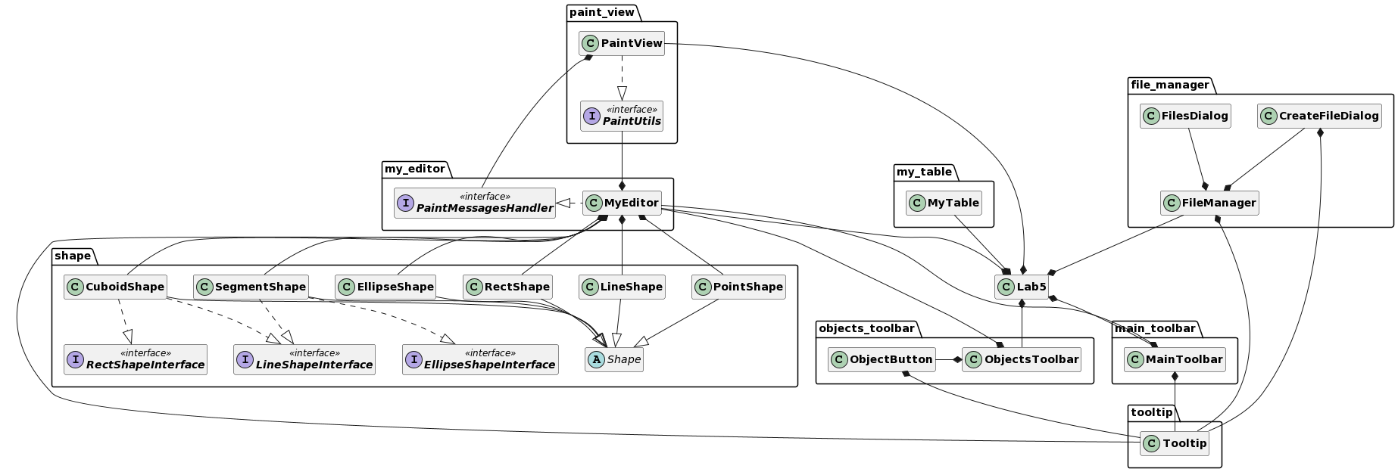

**Ілюстрації виконання програми**

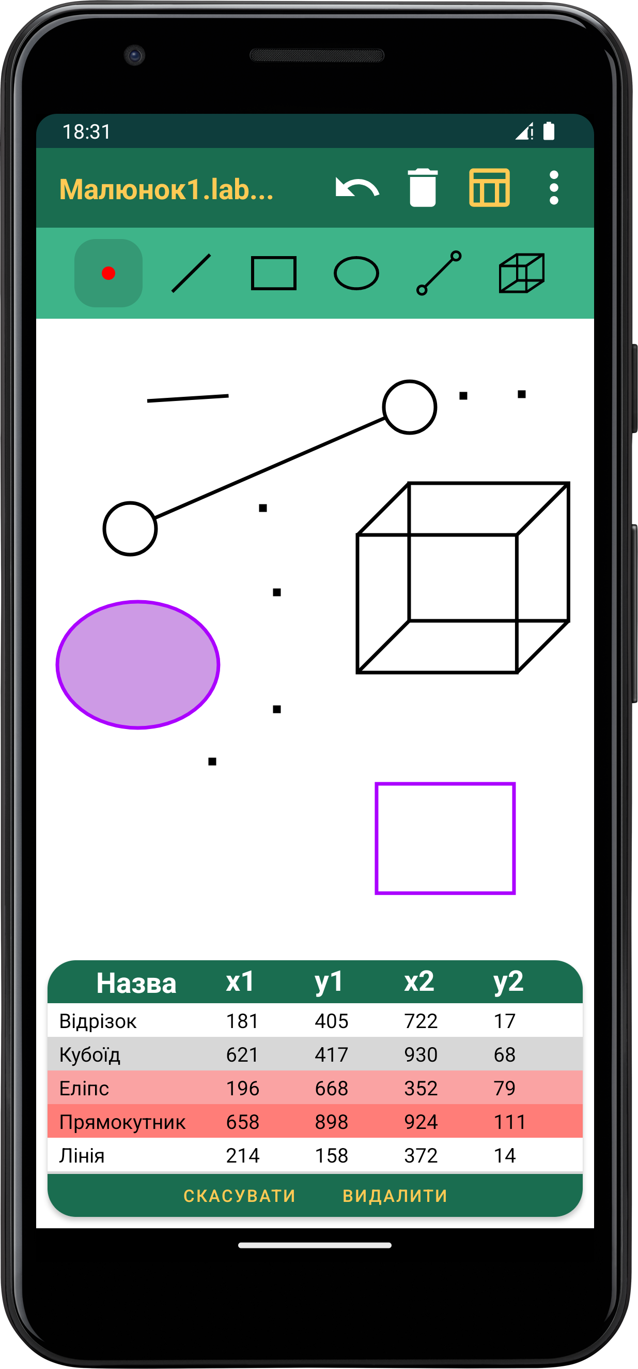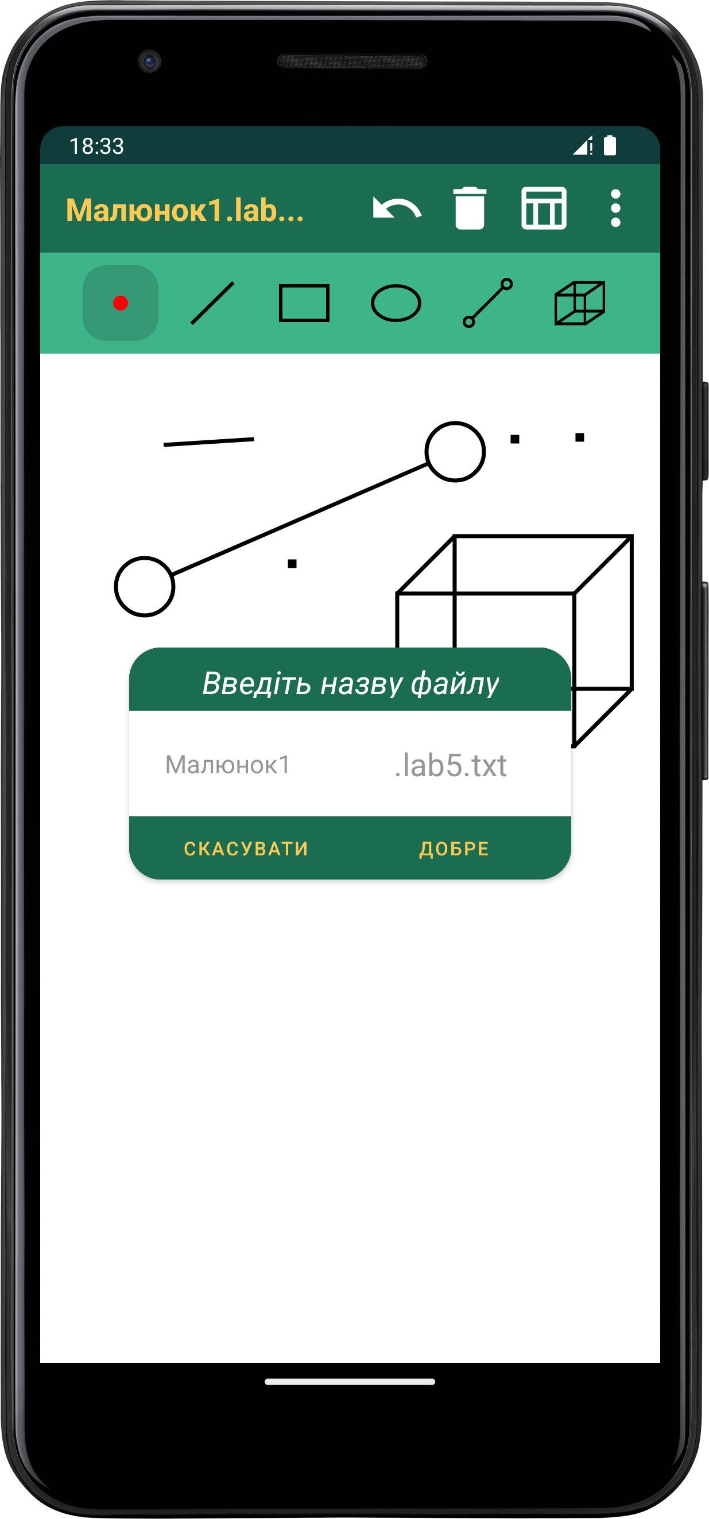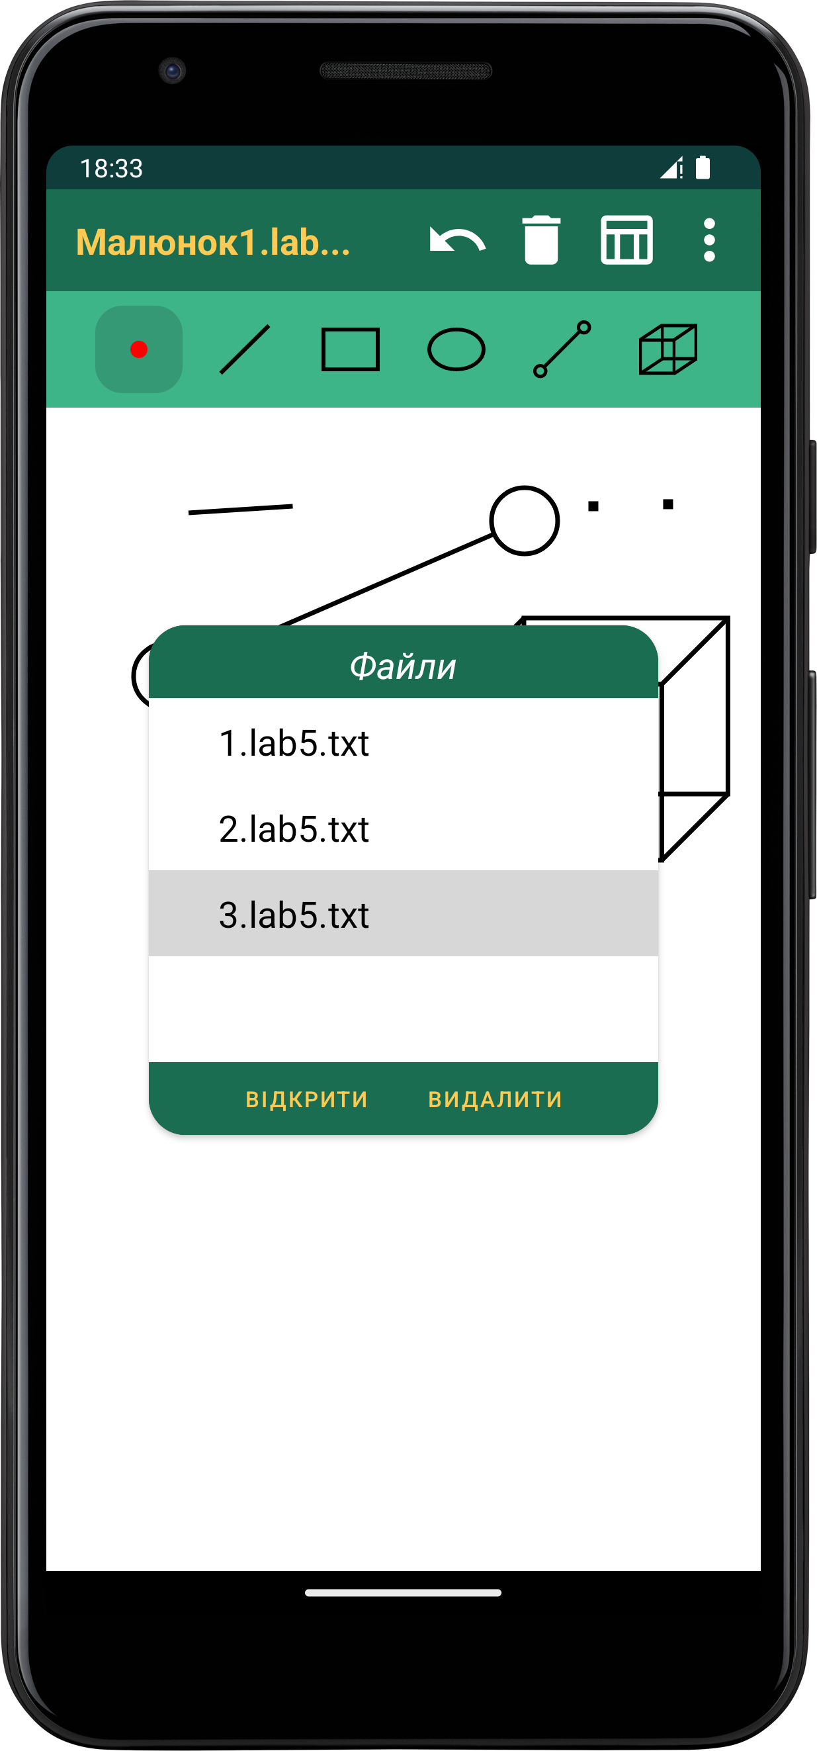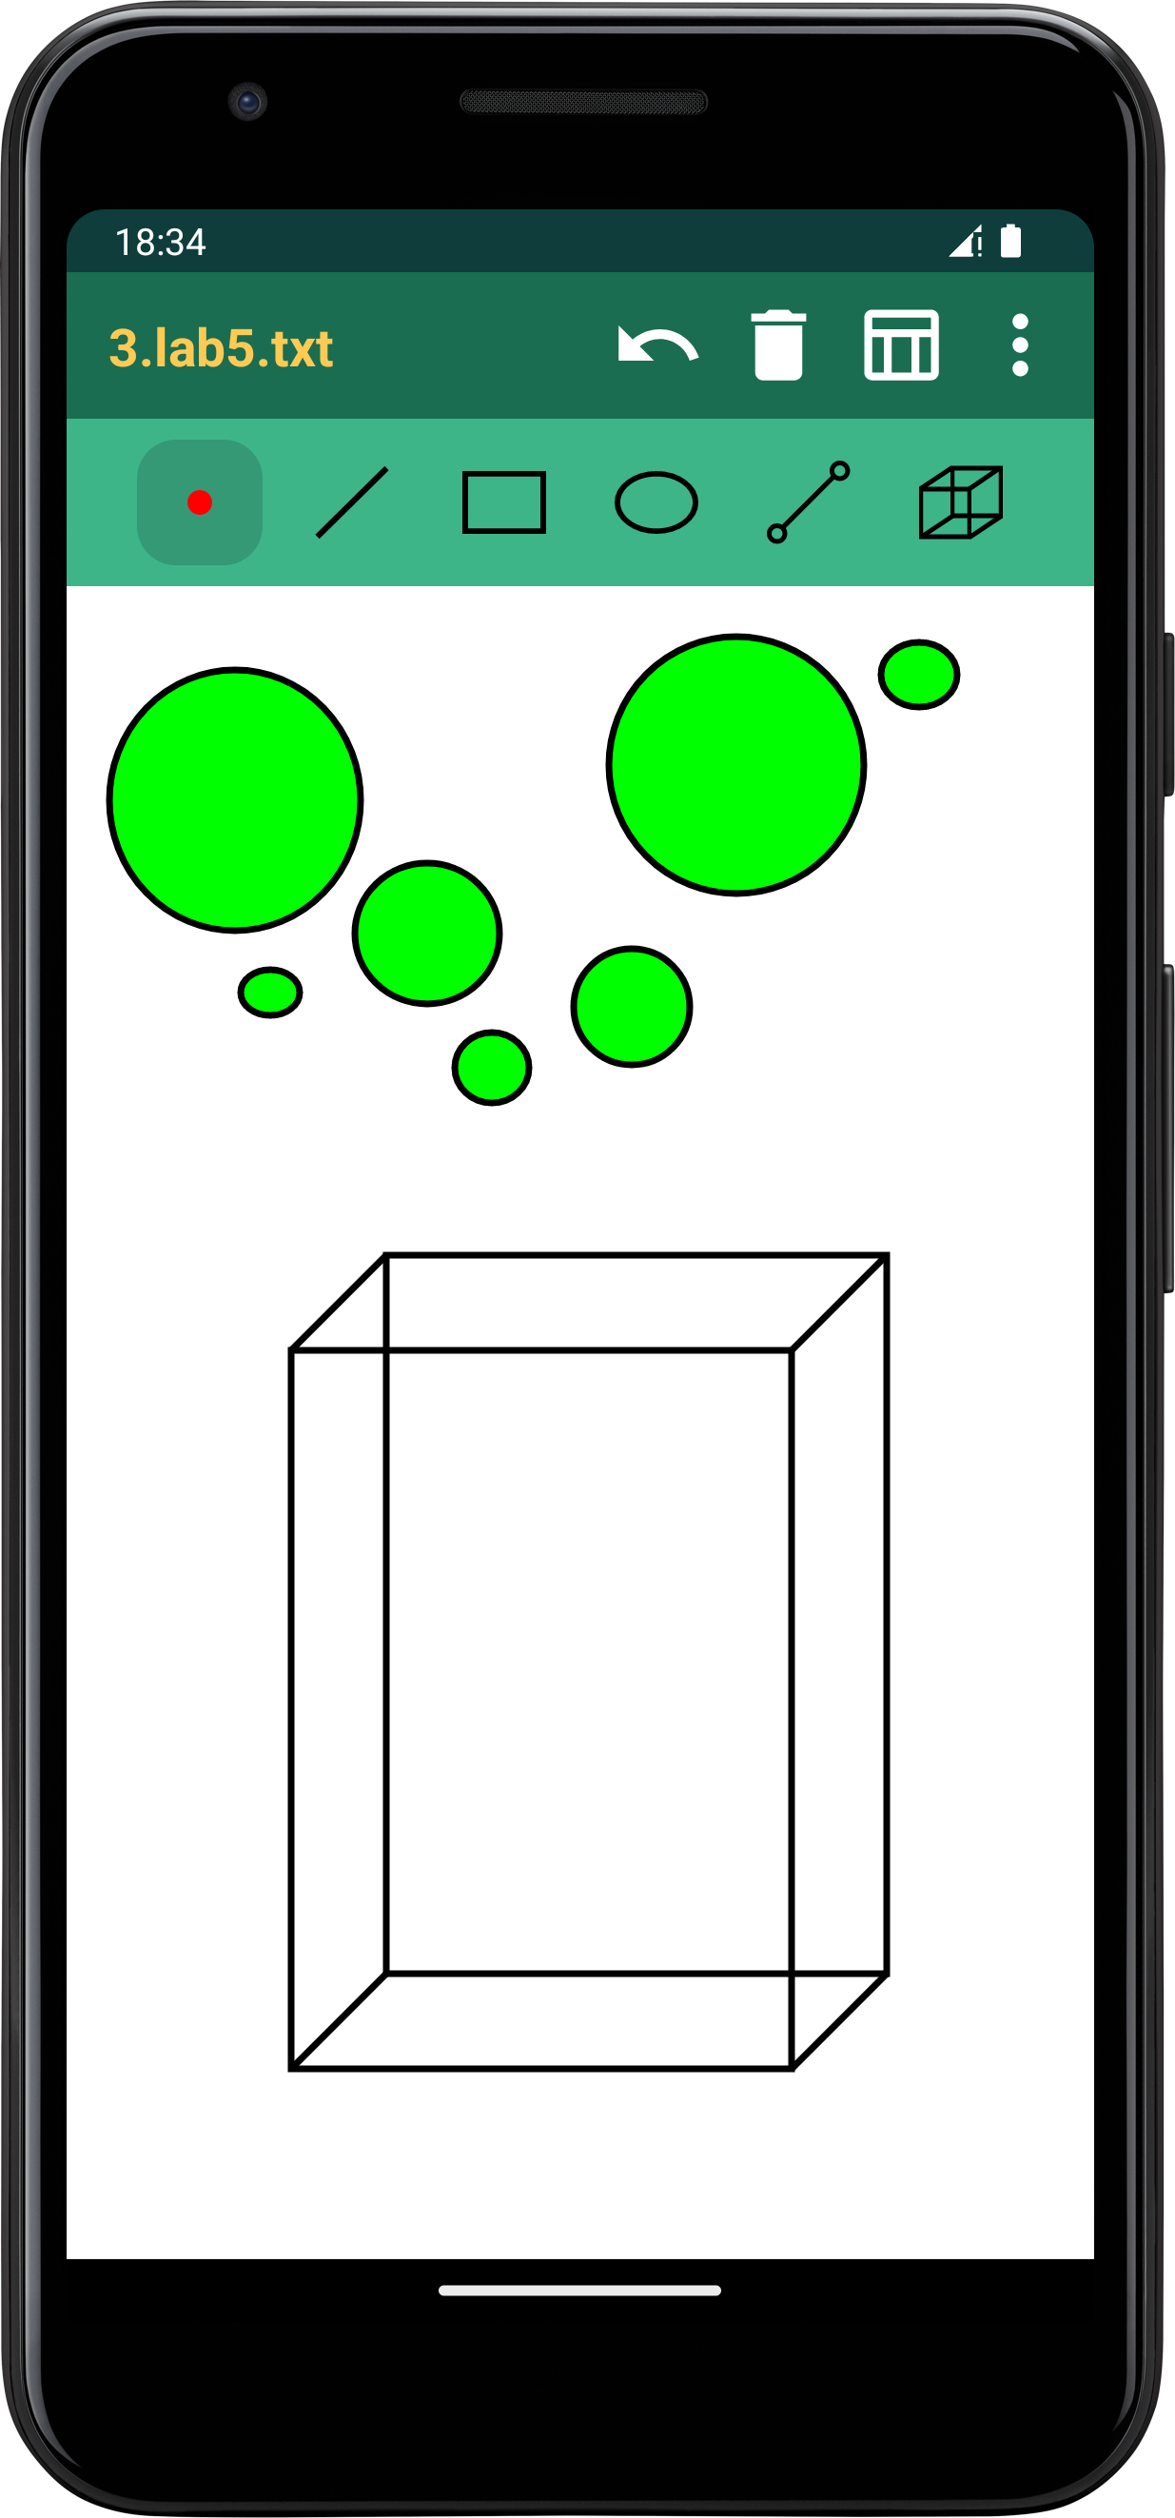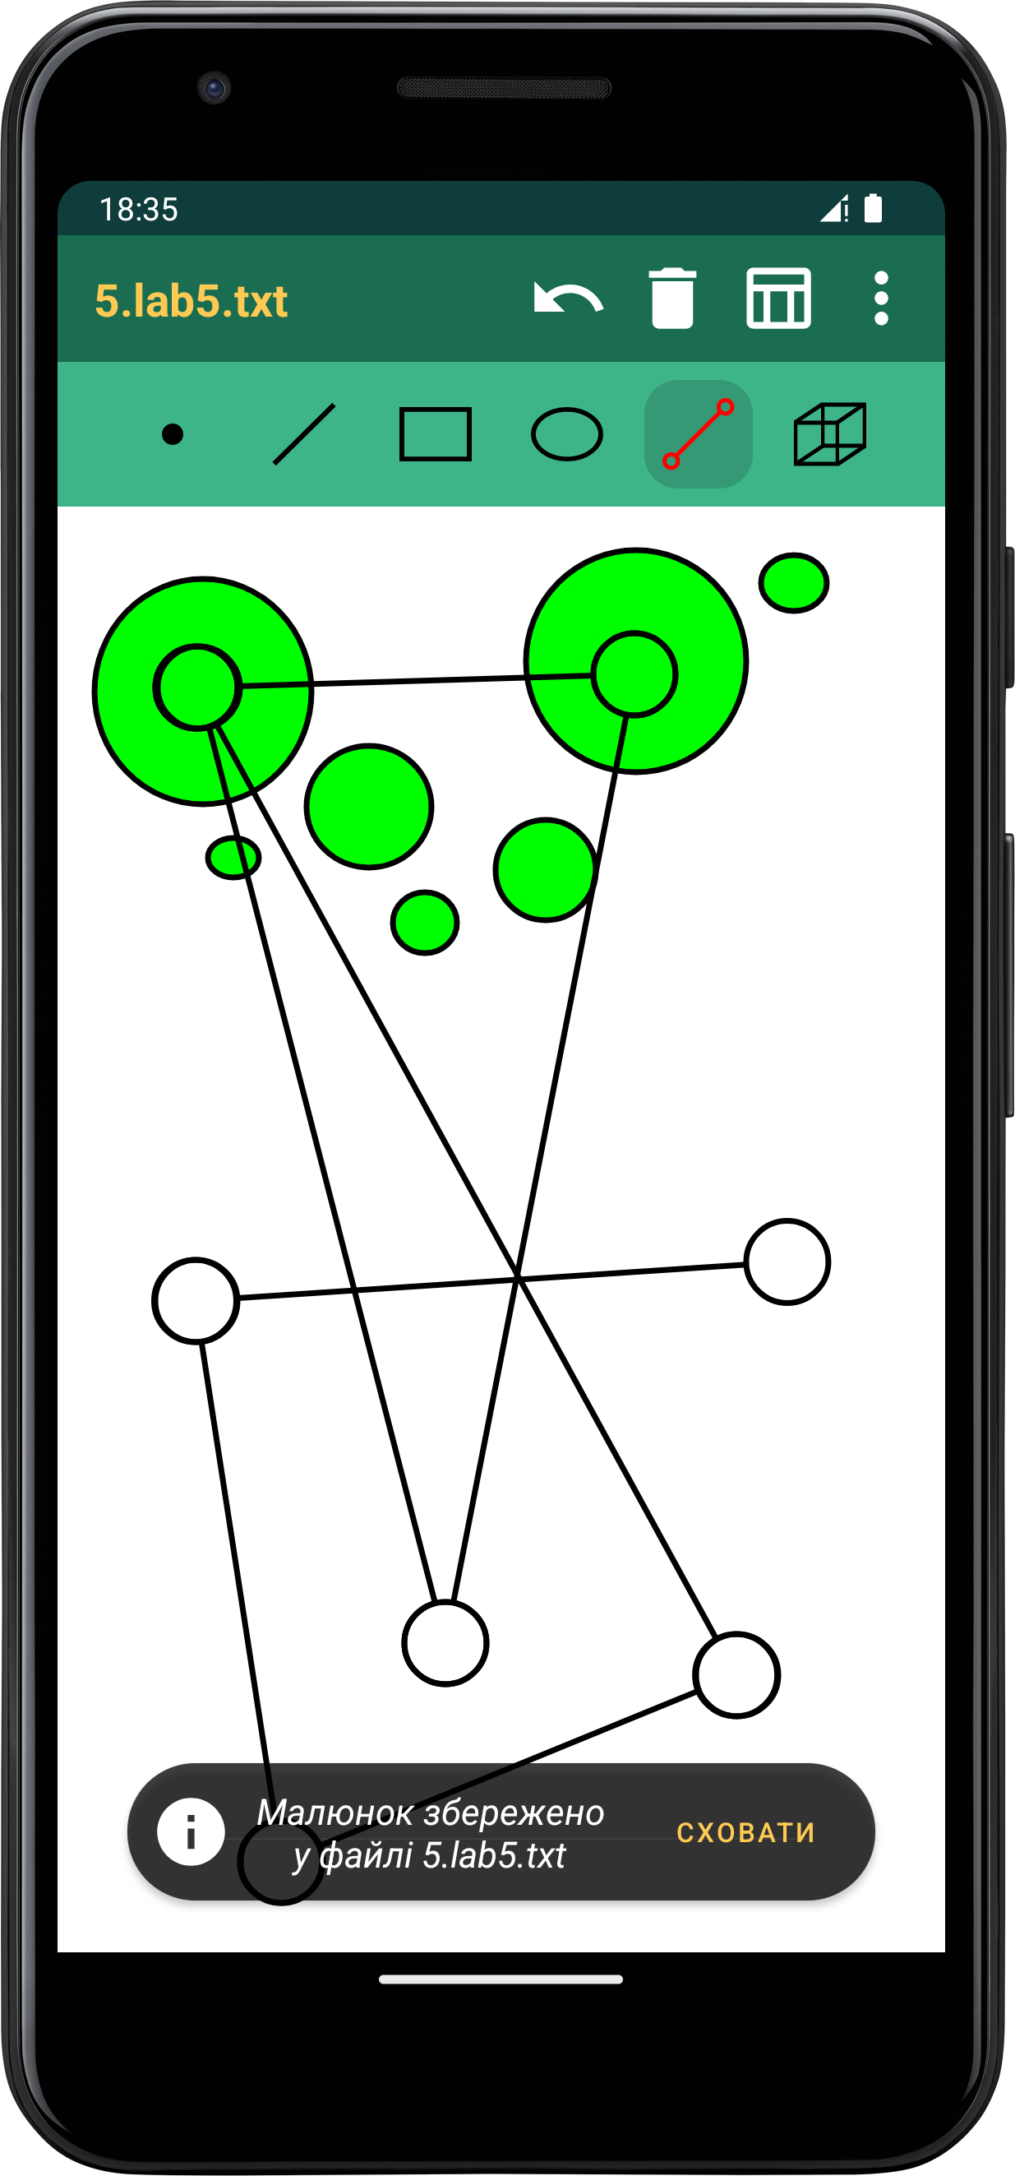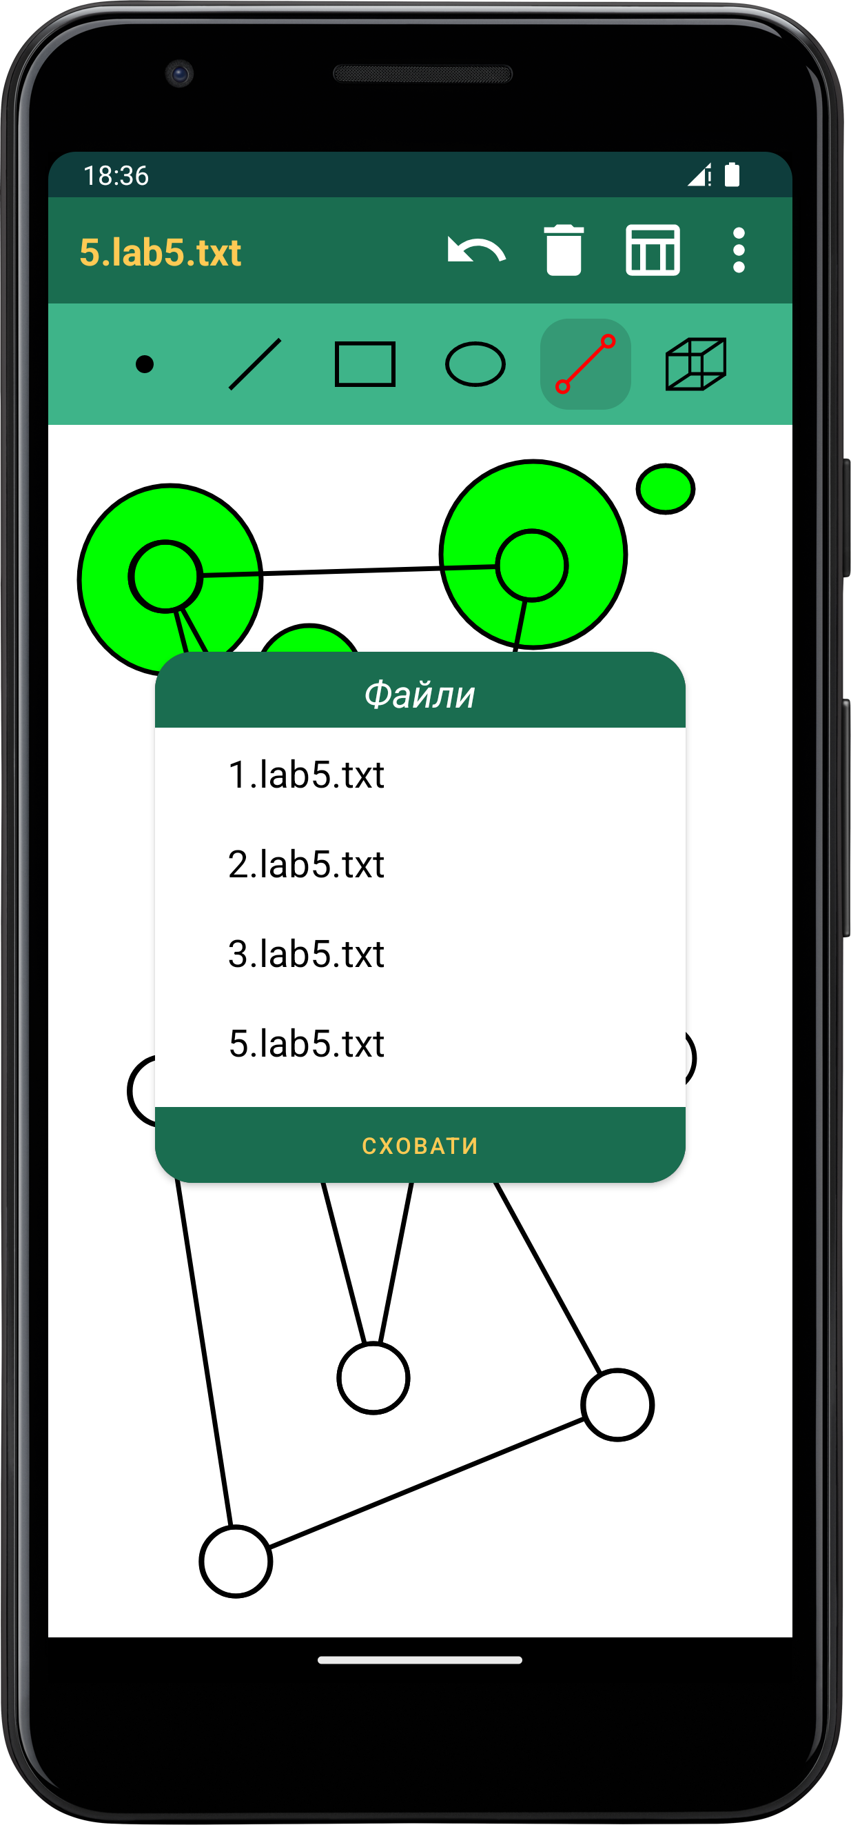

**Висновки**

Під час виконання цієї лабораторної роботи я запрограмував багатовіконний інтерфейс в об’єктно-орієнтованому стилі для раніше створеного графічного редактора, написаного на мові програмування ***Kotlin*** та доступного для платформи ***Android***. Зокрема було реалізовано вікно таблиці, що дозволяє зручно маніпулювати уже намальованими фігурами. Окрім цього тепер користувач матиме можливість зберігати малюнки у файли (формату ***.txt***), оскільки я додав до наявного функціоналу програми базові операції для роботи з файлами (створення, читання, оновлення та видалення). Останнім нововведенням було унеможливлення одночасного створення декількох екземплярів класу ***MyEditor*** за допомогою шаблону ***Singleton***.